**Delivery mobile robot**

After the coronavirus pandemic, the world went to reduce contact and crowding among people

So the number of service workers should have decreased as much as possible. Easy and hard work, but starting from easy will be easier to execute on the ground.

These services such as delivery of orders, cooking, customer guidance, and other works in which man can be replaced by robot.

This mobile robot helps people to deliver their orders to home from where they request it, and enter the password to open the box.

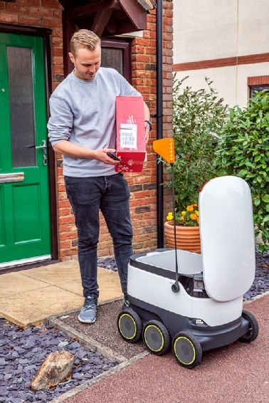

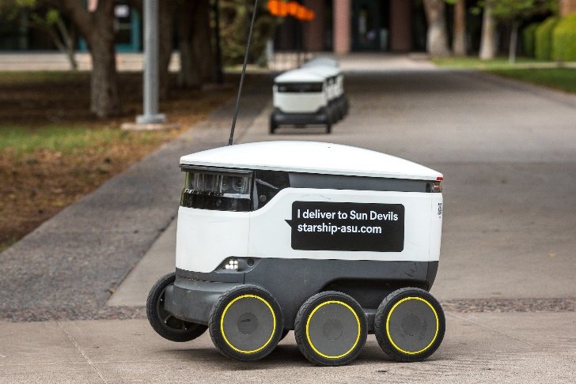

**Components :**

Keypad

Wifi module MKR 1000 (1000-1800 L.E) from aboard

Pi camera (800-1000 L.E)

GPS module A9G GSM (600 L.E)

Servo motor

Knowledge requirment:

Computer vision :

<https://www.youtube.com/playlist?list=PLf7L7Kg8_FNxHATtLwDceyh72QQL9pvpQ>

Digital image processing :

<https://www.youtube.com/playlist?list=PLZ9qNFMHZ-A79y1StvUUqgyL-O0fZh2rs>

SLAM course:

<https://www.youtube.com/watch?v=U6vr3iNrwRA&list=PLgnQpQtFTOGQrZ4O5QzbIHgl3b1JHimN_&ab_channel=CyrillStachniss>

SLAM and Navigation introduction:

<https://www.youtube.com/watch?v=IH_n9bfy-nM&list=LL&index=3&ab_channel=ROBOTISOpenSourceTeam>